Phase 3 – Leave no one behind!
Training on Disability-inclusive Health in Humanitarian Action


Introduction to disability-inclusive Health: Amplifying changes towards an inclusive humanitarian Health Response

When? November 5-7 (3 days)

Where? Berlin, Germany (Venue TBC)

Language? English (and International Sign upon request)

Who is invited? Humanitarian staff with programming, coordination and/ or technical roles in their organizations (International Organizations, NGOs, and Organizations of Persons with Disabilities) in the Health sector. Participants should have experience in humanitarian Health programming, good command of English, and be able to attend all training days in Berlin.

To encourage up-take and an effective learning experience, we highly encourage at least two participants per organisation or department. To apply, please fill out the pre-registration form by October 12. Successful applicants are selected based on pre-defined criteria and will be informed per email after the application deadline. The participant’s number is limited to max. 25 persons. The training is free of charge. Any related travel, accommodation and per diem costs need to be covered by the participants. We aim to provide the training as accessible as possible for persons with disabilities. Reasonable accommodation adjustments will be available upon request.
© William Daniels Handicap International

Objective
As part of Phase 3 of the Leave No One Behind project and in collaboration with International Rescue Committee, Médecins Sans Frontières, Inclusion Africa, United Disabled Persons of Kenya, and the Differently Talented Society of Kenya, a learning package has been developed on disability-inclusive Health through adaptation of the Disability Reference Group’s modules on Inclusive Humanitarian Action to the Health context, including the development of two additional modules on Informed Consent and Health Workforce.
In this training, participants will:
- Deepen understanding of disability-inclusive humanitarian Health in line with the IASC Guidelines on Inclusion of Persons with Disabilities in Humanitarian Action,
- Expand capacities in disability-inclusive Health programming and coordination reflecting all phases of the humanitarian project and program cycle,
- Understanding barriers faced by persons with different disabilities to Health services,
- Increase knowledge on accessibility, universal design, and reasonable accommodation
- Gain experience in obtaining informed consent and creating an inclusive health workforce,
- Learn about each other’s good practices, entry points for change and lessons learnt on inclusive programming

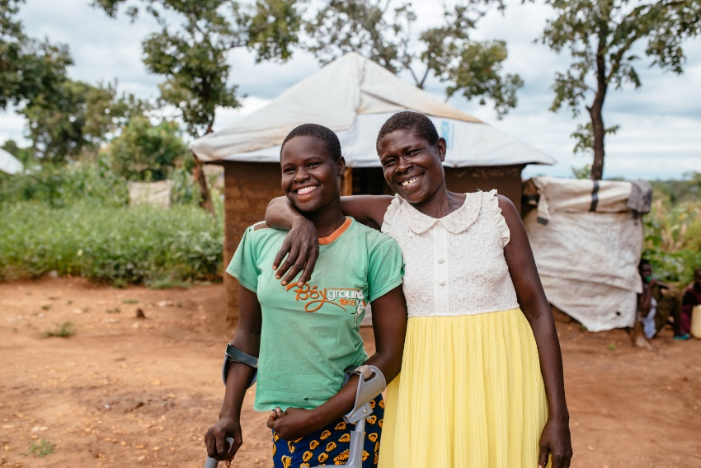
Methodology
The training promote inter-agency exchange and synergies. We will facilitate the training with an engaging and interactive approach offering a mix of lectures, group work, and discussions. To tweak the content to your interests, we ask that you fill out a pre-interest assessment where you will also rank the available training modules based on your interest. Following the workshop, participants receive certificates and training materials.
To apply: Please fill out this registration form by 12th October and you will be contacted with a final confirmation shortly after.
© Handicap International e.V.
More information: Visit the project website or send your questions to LeaveNoOneBehind@deutschland.hi.org

