Mapping of Commonly Used Protection Needs Assessment Tools in 6 countries of East and West Africa:

Somalia, South Sudan, Uganda, Niger, Nigeria, and Cameroon
Stephen Perry
December 2023
Executive Summary
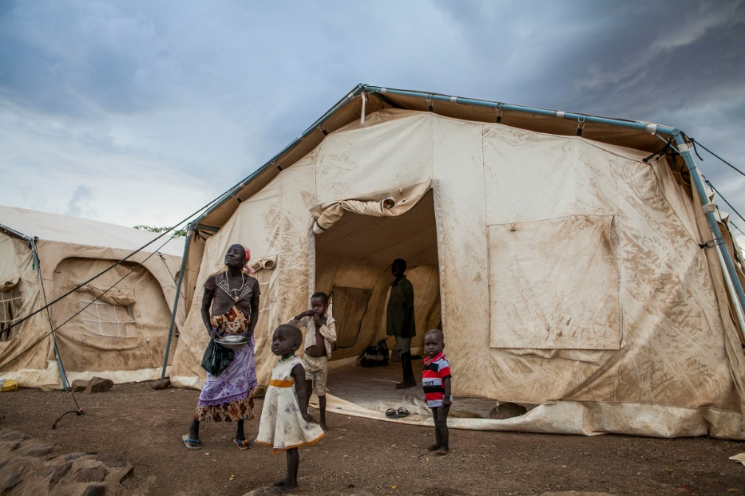

Executive Summary
The third phase of the “Leave No One Behind!” (LNOB) project focuses on mainstreaming disability in global and local humanitarian action in line with the Inter-Agency Standing Committee’s (IASC) Guidelines on Disability Inclusion. It is financed by the German Federal Foreign Office and implemented by Handicap International e.V., Christian Blind Mission (CBM), and the Institute for International Law of Peace and Armed Conflict (IFHV) at the Ruhr-University Bochum. This study is an integral part of the "leave no one behind" agenda. Recognizing the gaps in the tools and procedures used by Humanitarian Country Teams, findings from this mapping exercise will be instrumental in crafting recommendations to enhance the disability-inclusive perspective in protection needs assessment.
The study mapped the protection needs assessment tools both at the global level, and how tools are utilized in six pilot countries in East and West Africa, including Somalia, South Sudan, Uganda, Niger, Nigeria, and Cameroon. By contrasting on-the-ground practice against existing global guidance, it aims to enrich the understanding of how tools vary due to the rapidly changing humanitarian sector and specifically where targeted support could lead to more effective tools. Over 110 global needs assessment resources were identified for inclusion in this review at the global level. A survey of key informants identified by project focal points in the six pilot countries was undertaken in April 2023 to understand basic knowledge and use of protection needs assessment tools. Volunteers from this survey were interviewed in May and June 2023 to contribute insights on the actual use of needs assessment tools, and 2023 humanitarian assessments and local tools used to produce it were assessed.

Key Findings
This mapping exercise assessed disability-inclusive humanitarian needs assessment tools, particularly those utilized within the context of the Protection Cluster. Despite notable advancements in disability inclusion, the study revealed inconsistencies and areas for further improvement:
- Firstly, although a high degree of awareness for the IASC Guidelines on Inclusion of Persons with Disabilities in Humanitarian Action was noted among key informants, the rapid turnover of personnel in the sector combined with a continuous introduction of new tools creates a certain degree of fatigue and possibly confusion, and affects utilization of older needs assessment tools that continue to have value in terms of participatory processes and analytic methods they advocate.
- Second, efforts to promote more disability-inclusive tools need to recognize the implications of three developments in the humanitarian needs assessment process, including the pervasiveness of Multi-Sector Needs Assessments (MSNAs), the introduction of the Joint Intersectoral Analysis Framework (JIAF) to estimate the number of Persons in Need, and, third, how OCHA's recent “Flagship Initiative” currently being piloted in two LNOB countries (Niger and parts of South Sudan) could be helpful from a disability inclusion perspective.
The Flagship Initiative, initiated by the UN's Emergency Relief Coordinator, is a three-year pilot program aimed at transforming the current supply-driven humanitarian aid system into one that is less bureaucratic and more responsive to the needs of affected people, allowing country-level reinvention of coordination and response solutions in Niger, Colombia, the Philippines, and South Sudan. Humanitarian Country Teams in pilot countries have been encouraged to innovate with needs assessment processes leading to different processes being followed for the 2023 Humanitarian Needs Overviews, as was the case of Niger.
- Third, the mapping also revealed that the widely advocated Washington Group Questions are actually under-utilized. Handicap International (HI) has disseminated guidance on how these tools can be used in humanitarian contexts, including training resources aimed at managers, survey designers and enumerators. Large multi-sector needs assessments that are frequently the cornerstone of the humanitarian needs assessment process use the Washington Group questions with varying success across different contexts, if at all.
- Fourth, key informants responding to an anonymous survey report that Organizations of Persons with Disabilities (OPDs) rarely or only sometimes take part in the Protection Cluster’s needs assessment process is a useful insight. OPDs need to be targeted to a greater extent in humanitarian response process by making needs assessment tools more accessible. As tools change, being more intentional about OPD involvement seems critical.
- Finally, many of the global needs assessment resources reviewed in the study underscore the importance of robust disability-disaggregated humanitarian indicators. However, among the resources reviewed, only the IASC Guidance provides even a preliminary (and very incomplete) list of disability-inclusive indicators. As a result, very little consistency exists regarding what kinds of questions are asked, and how.
Overall, the findings emphasize the necessity for continuous evolution and improvement of tools and methodologies, ensuring disability inclusion throughout the entire Humanitarian Program Cycle.

Key Recommendations
Three specific recommendations emerged from this exercise:
- Better, and more disability-inclusive questions for surveys, monitoring tools, focus group discussion guidelines, and observation checklists would be appreciated by many in the humanitarian system who work at the local level and are doing their best to ensure the tools they put out in the field are as inclusive as possible. This would enable the system to better meet the needs of persons with disabilities.
- Technical support should be provided to make the MSNAs it produces deliver more useful data focused on persons with disabilities. This could involve contributing to discussions about making their household surveys compatible with the Washington Group methodology in all the settings where they are contracted to carry them out. Where capacity exists, support to Information Management Officers and REACH teams can be provided to develop methods to better integrated the Washington Group recommended methodologies and the related analysis and interpretation of data.
- Technical support should also be provided to the Office for the Coordination of Humanitarian Affairs (OCHA) at both the global and country levels to improve the JIAF's ability to effectively work with disability-disaggregated data where it exists in order to raise the visibility of Persons in Need with disabilities in the HNO analysis.

Humanity & Inclusion, “Disability Data in Humanitarian Action”, https://www.humanity-inclusion.org.uk/en/projects/disability-data-in-humanitarian-action

