Phase 3 – Leave no one behind!
Training on Disability-inclusive WASH in Humanitarian Action

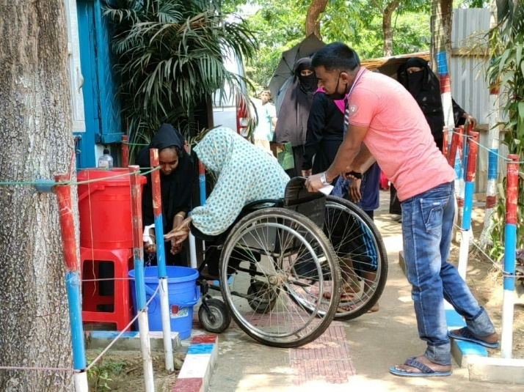
Introduction to disability-inclusive WASH: Amplifying changes towards an inclusive humanitarian WASH Response

When? June 11-13 (3 days)

Where? Berlin, Germany (Venue TBC)

Language? English (and International Sign upon request)

Who is invited? Humanitarian staff with programming, coordination and/ or technical roles in their organizations (International Organizations, NGOs, and Organizations of Persons with Disabilities) in the Water, Sanitation, and Hygiene sector. Participants should have experience in humanitarian WASH programming, good command of English, and be able to attend all training days in Berlin.
© Handicap International e.V.

To encourage up-take and an effective learning experience, we highly encourage at least two participants per organisation or department. To apply, please fill out the pre-registration form by June 1. Successful applicants are selected based on pre-defined criteria and will be informed per email after the application deadline. The participant’s number is limited to max. 25 persons. The training is free of charge. Any related travel, accommodation and per diem costs need to be covered by the participants. We aim to provide the training as accessible as possible for persons with disabilities. Reasonable accommodation adjustments will be available upon request.

Objective
As part of Phase 3 of the Leave No One Behind project and in collaboration with UNICEF, Malteser International, German Toilet Organisation, WaterAid, and Inclusion Africa, a learning package has been developed on disability-inclusive WASH through adaptation of the Disability Reference Group’s modules on Inclusive Humanitarian Action to the WASH context, including the development of two additional modules on Disability-Inclusive Community Engagement and Disability-Inclusive Menstrual Health & Hygiene.
In this training, participants will:
- Deepen understanding of disability-inclusive humanitarian WASH in line with the IASC Guidelines on Inclusion of Persons with Disabilities in Humanitarian Action,
- Expand capacities in disability-inclusive WASH programming and coordination reflecting all phases of the humanitarian project and program cycle,
- Understanding barriers faced by persons with different disabilities to WASH facilities and services,
- Increase knowledge on accessibility and universal design,
- Gain experience in meaningful disability-inclusive community engagement,
- Learn about each other’s good practices, entry points for change and lessons learnt on inclusive programming

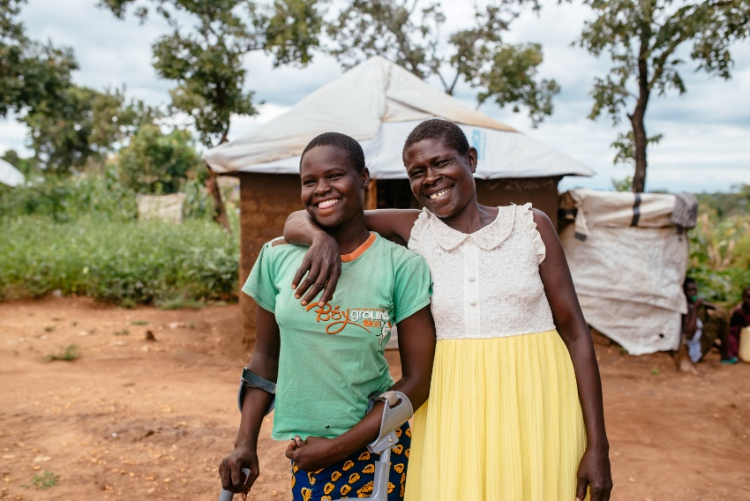
Methodology
The training promote inter-agency exchange and synergies. We will facilitate the training with an engaging and interactive approach offering a mix of lectures, group work, and discussions. To tweak the content to your interests, we ask that you fill out a pre-interest assessment where you will also rank the available training modules based on your interest. Following the workshop, participants receive certificates and training materials.
To apply: Please fill out this registration form by 1st June and you will be contacted with a final confirmation shortly after.
More information: Visit the project website or send your questions to LeaveNoOneBehind@deutschland.hi.org
© Handicap International e.V.

